**withColumn()**

The **withColumn()** functions is used to add or replace a column in a DataFrame. It allows us to create a new DataFrame by specifying the name of the column and the transformation logic to derive the values of that coumn.

Here's the syntax for using **withColumn()**:

new_df = old_df.withColumn(column_name, expression)

Breakdown of the components:

* **new_df**: It represents the new DataFrame obtained after adding or replacing the specified column.
* **old_df**: It is the original DataFrame to which the new column is being added or replaced.
* **column_name**: It is a string that represents the name of the column you want to add or replace.
* **expression**: It is the transformation logic used to derive the values of the new column.

Here are the examples to the usage of **withColumn():**

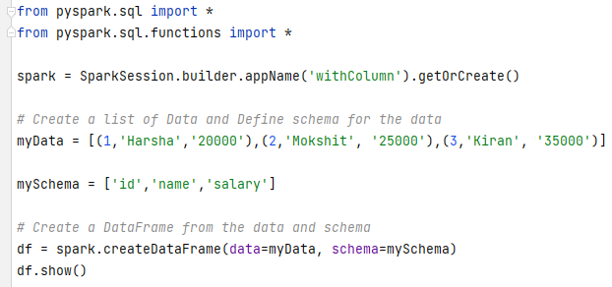

OutPut:

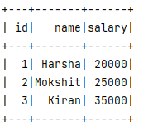

1. Adding a new column with constant value.

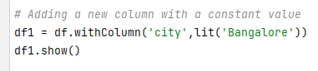

Output:

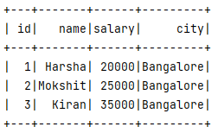

1. Adding a new column by applying a transformation on existing columns.

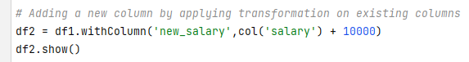

Output:

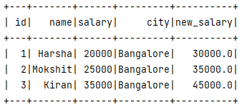

1. Replacing an existing column with a modified version.

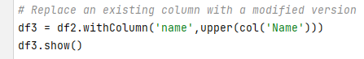

Output:

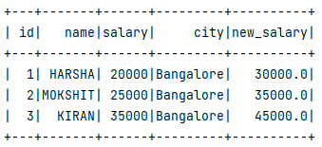

1. Adding a new column based on a conditional expression.

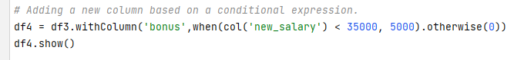

Output:

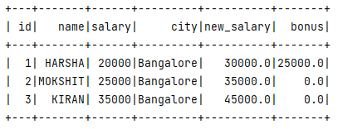

1. Deriving a new column by combining multiple columns

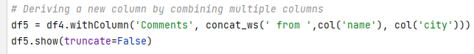

Output:

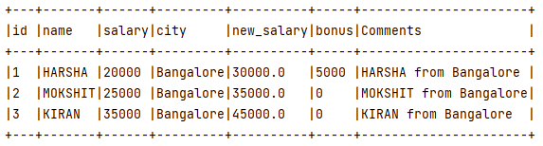

**withColumnRenamed()**

**withColumnRenamed()** is a DataFrame method used to rename a column in a Spark DataFrame. This method allows you to create a new DataFrame with the same data as the original one but with the specified column name changed. The original DataFrame remains unchanged.

The syntax for withColumnRenamed() is as follows:

DataFrame.withColumnRenamed(existing, new)

Breakdown of the components:

* **Existing**: The name of the column you want to continue.
* **New**: The name name you want to assign to the column.

Here are the examples to the usage of **withColumnRenamed():**

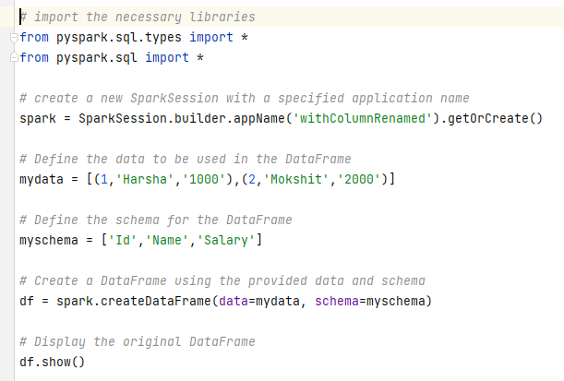

Output:

1. Renaming the column

Output:

